**20IT6205A: AGILE SOFTWARE DEVELOPMENT**

**Home Assignment**

**A.Y: 2022-23**

**Name: M.J.N.V.Sai Roll No : 208W1A12A0**

**1.** **Name of the project:** Stock Management Application Using ASP . Net Widows Forms

**2. Describe the application/ software/ prototype/ product :** Manages the stocks and products of

an reputated company.

**3. Objectives of application/ software/ prototype TV/product with respect to HOT analysis framework (In bullet points)**

* In human perspective, the user can easily understand the company up and downs by seeing the monthly, yearly stocks and products.
* In organizational perspective, the manager can easily understand the company up and downs by seeing the monthly, yearly stocks and products.
* In Technological perspective, the developer can easily understand the company up and downs by seeing the monthly, yearly stocks and products.

**4. Team Forming : Give the details of your team in the below table format**

|  |  |  |  |
| --- | --- | --- | --- |
| **Student’s name** | **Student’s ID** | **Department of Faculty** | **Electronic mail** |
| M . J . N . V . Sai | 208W1A12A0 | IT | 208w1a12a0@vrsec.ac.in |
| Md . Rizwanullah | 208W1A1299 | IT | 208w1a1299@vrsec.ac.in |
| K . Prabhuram | 208W1A1288 | IT | 208w1a1288@vrsec.ac.in |

**5. Describe the role schema with respect to your project (In tabular form) and elaborate on your role.**

|  |  |  |
| --- | --- | --- |
| **Student’s name** | **Student’s ID** | **Role schema** |
| M . J . N . V . Sai | 208W1A12A0 | Form Designing part |
| Md . Rizwanullah | 208W1A1299 | Adding Functionality |
| K . Prabhuram | 208W1A1288 | Deployment part |

**My details of my role:**

* In my role , I have to design a windows form which is interactive with both user and customer and contains main component like Login, Signup, Stocks and Products form, Crystal Report generation.

**6. Your team is told that if the project it is working on is successfully completed on time, the team will receive a bonus. Five options for bonus allocation are outlined below. Please explain how each option might influence team cooperation, and select the option you prefer. (In tabular form only)**

|  |  |  |  |
| --- | --- | --- | --- |
|  | **Personal Bonus**  **(% of the total bonus)** | **Team Bonus**  **(% of the total bonus)** | **How this option may influence teammates cooperation** |
| **A** | **100** | **0** | He / she may lost the interest of doing work in a team |
| **B** | **80** | **20** | it may be increase his team sprit in next project |
| **C** | **50** | **50** | There will be no influence. |
| **D** | **20** | **80** | his individual interest will decrease. |
| **E** | **0** | **100** | it will effect in his individual skill and interest of work. |

**7. Give out the schedule of your project (for at least 2 weeks) by calculating the iterations and business days. (In tabular format)**

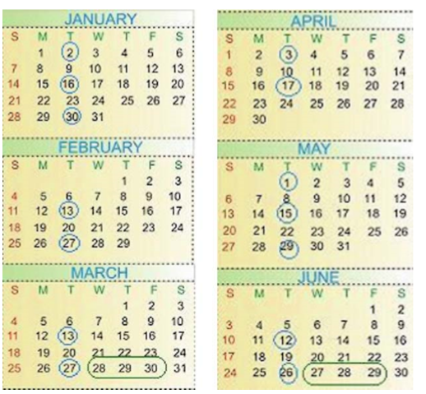

|  |  |  |  |
| --- | --- | --- | --- |
| **S.NO** | **DAYS** | **DESCRIPTION** | **SCHEDULE** |
| 1. | Business Day | on these days we plan the sprit of an  project and on which day what we have to delivar | 2 weeks |
| 2. | Development Day | on these days we will see the progress and evaluation of works allotted . | 2 weeks |
| 3. | Deployment Day | on these days we deploy the application dynamically. | 1 week |

**8. List few functional requirements:**

* The functional requirements are :
* A system, Microsoft Visual Studio 2022 version, Asp .net framework, windows forms, package manger console window, SAP crystal report installation.

**9. What metaphors would you suggest for your project? Explain why?**

**Metaphor :** A project’s path is like an Planning a Road Trip

**Explanation :** Road trip! The planning out of a project path is a whole lot like having to plan a road trip. This particular road trip must pass through specific locations across the country, in a certain amount of time, in a specific vehicle with miscellaneous activities scattered throughout.

Reaching the significant destinations is like hitting major milestones. Planning out the drive time and driver arrangement is like creating a project schedule with work durations of each party involved.

**10. Elaborate on the Time-Related Problems that you faced in your Project.**

* During the semester examinations it is hard to manage the time we have to postpone the works continuously due to exams.

**11. Draw a graph describing the estimation development and actual development with development days in x –axis and no of hours your team worked on project on y- axis. There will definitely be a delay in the actual development, Explain why?**

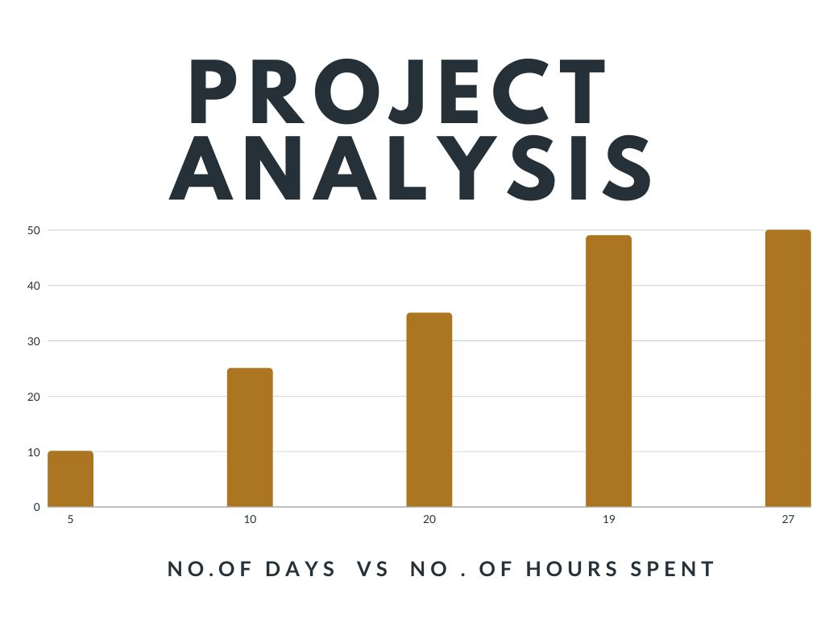

**12. Define Quality with respect to your project and how do you measure it?**

* **Q**uality in our project refers to how better our project identifies the Company’s Financial and produce an alarm in order to alert him.
* We measure the quality of our project by testing it in various conditions such as the foggy conditions as well as dark conditions, and we also tested the accuracy of our project by using various deep learning techniques.

**13. Is your team diverse? If so, in what sense? Do you benefit from this diversity? If not, why? If so, how? If your team is not diverse, what is common to all the team members? Describe something specific.**

* Yes our team is diverse.
* In the sense that each and every one in our is specialized in either or the other fields. For example a person in our team is good at coding and the other person is good at the documentation and data collection and I am good at providing speeches or giving presentations regarding our project.
* Yes we were hugely benefitted from this type of diversity as a person good at documentation would not be good at coding or giving a presentation.
* A person knowing how to present the project would not know how to code the project and the person who know how to code the project might not know how to document the project or present the project. Thus this diversity has helped me a lot in the completion of our project.

**14. Describe a scenario that illustrates how diversity may harm agile teamwork. What characterizes such scenarios?**

* Sometimes during the progression of our project, most of the work will be depending upon the coding part of the project or the presentation part or the documentation part.
* If the team members are diversified, then most of the work must be done by one single person thus leading to stress and late submission of the task.
* In agile we have various sprints, and certain amount of work must be completed in that particular sprint time, but if only one particular person is working on that one particular task, then it is going to take long time to complete the task.
* Thus in such scenarios, diversity may harm agile team work, so in order to avoid such scenarios all the team members must take part in the completion of the work.

**15. Describe the learnings that we have achieved from your overall project work?**

* We learned many things from the completion of this project some of them are listed below.
* We have learnt how to make use of the Multi Task Cascaded Parent Forms, how many layers are present in it and how many have we used in our project.
* We have also learnt how to train the machine or a camera in order to capture the image of the driver and calculate the Sensus.

We have learnt how to make use of the various packages and libraries present in real world.